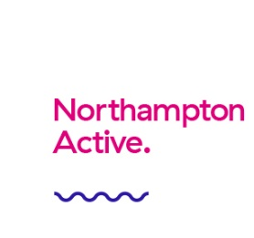
Acknowledgement Of Risk
BLOCK LETTERS PLEASE

Paddler Information
Full Name Age
House Number Post Code
Telephone Email

Medical Information
Do you have any medical conditions, for example asthma, diabetes, epilepsy etc YES NO
Please give details:
Do you have any disabilities or allergies that the centre should be made aware of? YES NO
Please give details:
Do you have any special requirements? YES NO
Please give details:

Emergency Contact Details
Name Relationship to you
Telephone Mobile

Photographs
We occasionally film or take photographs of our activities for publicity reasons, including reproduction on our website. If you do not agree to us using photographs or footage that includes yourself/your child, please tick the box

Safety & Risk Declaration
Please read all sections then write Y or N as appropriate | Y / N
I understand that all activities by their nature involve an element of risk which could result in personal injury, illness or death. Whilst the staff team will take every reasonable steps to ensure my safety, I understand they can not be held liable for my own actions, for which I must take responsibility, or for those of a third party.
I have completed and submitted a medical consent form. I do not have any medical conditions or illnesses other than those disclosed on my medical consent form.
I understand that I am not to participate in this activity if I am under the influence of alcohol or drugs.
I understand that all jewellery must be removed or covered before taking part in any of the activities.
I understand that I must take responsibility for any personal properties or valuables taken on the activity. Should I lose or damage my property it is not the responsibility of the centre to replace.
I understand that the quality of the water may vary and that there is rick of Weil's disease, and that if I have any concerns regarding this, I should speak to a staff member
I have been able to read the above relevant Terms and Conditions and agree with these.

If you have any questions or queries or am unsure of anything in the above, please speak to member of the centre team
A parent/guardian must sign below if the participant is under 18 years of age
I the legal parent/guardian of ............................................................ give consent for my child to take part in this activity. In the event of an incident or accident involving my child, I agree to my child receiving first aid from a suitably qualified person and/or any medical or dental treatment, including but not without limitation to anaesthetic and blood transfusion, which may be considered necessary by a registered medical practitioner.
Name Date Signature

I am over the age of 18 and confirm that all the information supplied above is correct
Name Date Signature

